MZUMBE UNIVERSITY

FACULTY OF SCIENCE AND TECHNOLOGY

DIPLOMA IN INFORMATION TECHNOLOGY

FINAL PROJECT REPORT

TITLE

QR CODE-BASED ATTENDANCE MANAGEMENT SYSTEM FOR EVENTS

PREPARED BY

YOUR NAME

REGISTRATION NUMBER

A PROJECT REPORT SUBMITTED TO THE FACULTY OF SCIENCE AND TECHNOLOGY IN PARTIAL FULFILMENT OF THE REQUIREMENTS FOR THE AWARD OF THE DIPLOMA IN INFORMATION TECHNOLOGY OF MZUMBE UNIVERSITY.

JULY, 2026

DECLARATION
I, ________________________________, declare that this project report is my own original work and has not been submitted to any other institution for any academic award.

Signature: ___________________

Date: _______________________

CERTIFICATION
This project report entitled "QR Code-Based Attendance Management System for Events" has been submitted for examination with my approval as the University Supervisor.

Supervisor Name:

_____________________________

Signature:

_____________________________

Date:

_____________________________

COPYRIGHT
No part of this report may be reproduced, stored in any retrieval system or transmitted in any form or by any means without prior written permission from the author or Mzumbe University.

DEDICATION
This project is dedicated to my beloved parents and family for their endless support, encouragement and prayers throughout my academic journey.
It is also dedicated to my lecturers and friends who inspired and supported me during the development of this project.

ACKNOWLEDGEMENT
I would like to express my sincere gratitude to Almighty God for granting me good health, strength and wisdom throughout the completion of this project.
I also extend my sincere appreciation to my supervisor for valuable guidance, constructive comments and continuous support throughout the project development.
Special thanks go to the lecturers of the Faculty of Science and Technology at Mzumbe University for the knowledge and skills they provided during my studies.
Finally, I would like to thank my family, friends and everyone who contributed directly or indirectly to the successful completion of this project.

ABSTRACT
Attendance management is an important activity in seminars, conferences, workshops and meetings. Many organizations still rely on manual attendance recording using paper registers, which often leads to long queues, inaccurate records, missing information and false attendance.
This project developed a web-based QR Code-Based Attendance Management System for Events to improve attendance recording. The system allows event organizers to create events, generate live QR codes, monitor attendance and produce attendance reports. Participants register, join events and record attendance by scanning a live QR code using a mobile device.
The system was developed using PHP, MySQL, HTML, CSS and JavaScript following the Agile software development methodology. Additional verification features such as device information, attendance windows and location verification were included to improve attendance reliability.
The developed system improves attendance speed, accuracy, record management and reporting while reducing manual errors and false attendance. The system provides a practical and affordable solution suitable for seminars, workshops, conferences and meetings.

CHAPTER ONE

INTRODUCTION AND PROBLEM DESCRIPTION

1.1 Background of the Study
Technology has become an important part of daily operations in organizations, institutions and public activities. Many manual tasks are now being replaced by digital systems because digital systems are faster, easier to manage and more reliable. Areas such as communication, record keeping, information sharing and data processing have improved because of the use of information systems.
Attendance management is one of the activities that is still handled manually in many events. In seminars, workshops, conferences and meetings, participants are often required to write their names and signatures on paper sheets when they arrive. Although this method is easy to understand and does not require technical knowledge, it becomes inefficient when many participants arrive at the same time.
Manual attendance recording can cause long queues at the entrance of an event. Participants may spend time waiting to sign the attendance sheet, and this may delay the start of the event. In addition, some participants may write unclear names, wrong phone numbers or incomplete information. This makes it difficult for organizers to prepare accurate records after the event.
Another challenge is poor record management. Paper-based attendance sheets can easily be lost, damaged or misplaced. When this happens, organizers may fail to confirm who attended the event. This is a serious problem in events where attendance records are used for certificate preparation, official reporting or evaluation of participation.
Manual attendance systems also create chances for cheating. A person may sign on behalf of another participant who is not present. Since the paper-based method does not verify the actual identity, device or location of the participant, it is difficult to prevent false attendance. This affects the trustworthiness of attendance records.
QR code technology provides a practical way to improve attendance management. A QR code can store information and can be scanned using a smartphone camera. In the proposed system, an event organizer creates an event and the system generates a live QR code for that event or attendance session. A participant who has joined the event scans the QR code using a mobile device, and the system records attendance automatically under the participant account.
The QR Code-Based Attendance Management System for Events is therefore designed to solve problems found in manual attendance systems. It supports event creation, participant registration, event joining, live QR code display, QR scanning, attendance storage, monitoring and report generation. The system also captures device and location information during attendance recording in order to support verification.

Figure: 1.1 Manual Attendance Process


Figure: 1.2 QR Code Attendance Process
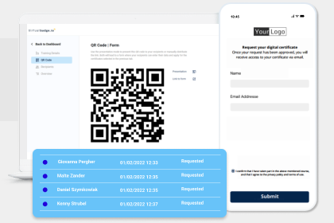

1.2 Problem Statement
Despite the availability of digital technologies, many event organizers still use paper-based methods to record attendance. These methods are slow and become difficult to manage when many participants attend an event. Long queues may occur, and the attendance process can disturb the event schedule.
Manual attendance records are also affected by human errors. Some participants may write wrong names, incomplete details or unreadable information. Duplicate entries may also occur when participants write their details more than once. These errors reduce the accuracy of attendance data.
There is also a high risk of false attendance. Since manual attendance does not verify the actual participant, one person may sign for another person. This makes attendance information unreliable, especially in events where attendance is used for certificates, reports or official confirmation.
Another problem is poor data management. Paper records can be lost, damaged or disorganized. Retrieving information from paper records is slow because organizers must check the sheets manually. Generating reports after the event also takes time and may contain errors.
Manual systems do not provide immediate attendance monitoring. Organizers cannot easily know the number of participants who have already attended while the event is still taking place. This limits quick decision making during the event.
Therefore, there is a need for a web-based attendance management system that can record attendance quickly, store records digitally, reduce errors, support monitoring and improve attendance verification. A QR code-based system is suitable because it is affordable, flexible and can be used with common mobile devices.

1.3 Project Objectives

1.3.1 General Objective
To develop a QR Code-Based Attendance Management System that improves the speed, accuracy and reliability of recording attendance during events such as seminars, workshops, conferences and meetings.

1.3.2 Specific Objectives
1. To design a system that generates a unique live QR code for each event or attendance session.
2. To allow participants to record attendance by scanning the event QR code using a mobile device.
3. To store user, event, participant and attendance records in a digital database.
4. To enable organizers to monitor attendance records after participants scan the QR code.
5. To generate attendance reports and statistics for record keeping and decision making.
6. To reduce manual errors and minimize false attendance recording.
7. To improve attendance verification using participant device information and location details.

1.4 Significance of the Study
This project is useful to event organizers because it reduces the time used to record attendance. Instead of writing names on paper, participants scan a QR code and the system records attendance automatically.
The project improves the accuracy of attendance data because records are stored directly in the database. This reduces problems such as unclear handwriting, missing information and duplicate manual entries.
The system improves record management because attendance information is stored digitally. Organizers can view attendance records, search information and generate reports without checking paper sheets.
The system also supports better verification. Since participants must log in, join an event and scan the live QR code during the attendance window, the system reduces chances of false attendance. Device and location details provide additional information for checking attendance validity.
The project is also important to participants because it provides a simple and faster way to record attendance. Participants only need a mobile device with a browser and camera access to scan the QR code.

1.5 Scope of the Study
The scope of this project is the development of a web-based attendance management system for events. The system covers user registration and login, event creation, venue selection, participant joining, live QR code generation, QR code scanning, attendance recording, attendance monitoring and report generation.
The system supports different user roles, including attendee, event organizer, organization administrator and system administrator. The attendee can join events and scan QR codes. The organizer can create and manage events. The organization administrator can manage venues and organization users. The system administrator can manage organizations and system settings.
The system does not include biometric authentication, facial recognition, payment services or integration with external platforms. It focuses on attendance management for events using QR code technology.

CHAPTER TWO

LITERATURE REVIEW

2.0 Introduction
This chapter reviews existing literature and technologies related to attendance management systems. It discusses manual attendance, biometric attendance, RFID attendance, web-based attendance and QR code attendance systems. The purpose of the review is to understand existing approaches, their strengths, weaknesses and the gap addressed by the proposed system.

2.1 Topic Review
Attendance management is the process of recording and managing the presence of people in an activity, class, meeting or event. Attendance records are important because they help organizers confirm participation, prepare reports and make decisions. In some events, attendance is also used to issue certificates or prove participation.
Manual attendance systems are widely used because they are cheap and simple. They involve the use of paper registers or sign-in sheets. However, manual systems are slow, especially when many participants arrive at the same time. They also depend on human writing, which may lead to errors and unclear records. Okokpujie et al. (2017) noted that manual attendance processes reduce operational efficiency because they depend heavily on human input.
Biometric attendance systems use unique human characteristics such as fingerprints, face or iris patterns. These systems improve security because biometric features are difficult to copy. However, biometric systems require special hardware and technical support. Jain, Ross and Prabhakar (2004) explained that biometric systems provide strong identification, but the cost and complexity of implementation may limit their use in some environments.
RFID attendance systems use cards or tags that are scanned by RFID readers. The systems are faster than manual registers and can record attendance automatically. However, RFID systems require cards, readers and maintenance. Want (2006) explained that RFID technology depends on supporting infrastructure, which may increase cost.
Web-based attendance systems allow attendance records to be collected using browsers and online forms. They are easy to access and can store data digitally. However, some simple web forms do not provide strong verification. A person may submit attendance without being physically present if the system does not check identity or location.
QR code attendance systems use Quick Response codes that can be scanned using smartphones. QR codes are affordable and easy to implement because most mobile devices have cameras. In an event environment, a QR code can be displayed by the organizer and scanned by participants. This reduces paperwork and speeds up attendance recording. Singh and Kumar (2020) explained that QR code applications can improve attendance recording and data management.

Figure: 2.1 QR Code Technology Example


2.2 Domain Review
Attendance systems are used in different domains such as education, business, public administration and event management. In educational institutions, attendance is used to monitor student participation in classes and academic events. In business organizations, attendance is used for meetings, staff training and official programs. In conferences and workshops, attendance is used to confirm participant involvement and prepare reports.
Manual attendance systems are still common in developing countries because they require little cost. However, they are not effective for events with many participants. They are also weak in data storage, data retrieval and verification.
Biometric systems are suitable for permanent institutions that require high security, such as offices and controlled facilities. However, they are less suitable for temporary events because setting up biometric devices can be expensive and time consuming.
RFID systems are suitable where participants already have cards or badges. They are fast, but they require RFID readers and tags. This may not be practical for small or temporary events with limited budgets.
QR code systems are more practical for events because they are low cost, flexible and easy to use. Participants can use smartphones to scan QR codes without requiring special cards or biometric devices. However, QR code systems need proper verification features to reduce QR sharing and false attendance.

Table: 2.1 Domain Review
System Type | Strengths | Weaknesses
Manual Attendance | Cheap and easy to start | Slow, error-prone and weak in verification
Biometric Attendance | Strong identity verification | Expensive and requires special hardware
RFID Attendance | Fast and automated | Requires cards, readers and maintenance
Simple Web Forms | Easy to access and store data | Weak verification if used alone
QR Code Attendance | Affordable, fast and suitable for mobile use | Requires proper login, QR validation and location support

2.3 Comparison of Related Studies
To strengthen the literature review, different studies and technologies related to attendance management were compared. The comparison shows that each technology has its own strength, but also has limitations. This helped to justify the need for the proposed QR Code-Based Attendance Management System with verification features.

Table: 2.2 Comparison of Related Studies
Author / Source | Technology / Approach | Strength | Weakness
Jain, Ross and Prabhakar (2004) | Biometric recognition | Provides high security and strong identity verification | Expensive and requires special biometric devices
Want (2006) | RFID technology | Fast and suitable for automated identification | Requires RFID cards, readers and maintenance
Okokpujie et al. (2017) | Facial recognition attendance | Reduces proxy attendance and improves user identification | Requires camera setup, processing power and technical support
Kumar and Bansal (2018) | Web-based attendance system | Improves storage, retrieval and report preparation | May have weak verification if used without identity checks
Singh and Kumar (2020) | QR code attendance applications | Low cost, easy to use and suitable for smartphones | QR codes can be shared if verification is weak
Google Forms (Google LLC, n.d.) | Online form attendance | Simple, accessible and stores data online | Does not strongly confirm physical presence
Proposed System | Live QR Code + Login + Device and Location Verification | Low cost, flexible and improves attendance verification | Depends on internet access, browser support and device permissions
The comparison shows that the proposed system combines the affordability of QR code technology with additional verification features. This makes it more suitable for temporary event environments compared to biometric and RFID systems, which require extra hardware. It is also stronger than simple online forms because it records device and location information during attendance scanning.

2.4 Problem Conclusion
The reviewed systems show that attendance management can be improved using technology, but each technology has limitations. Manual systems are simple but slow and unreliable. Biometric systems are secure but costly. RFID systems are fast but require additional devices. Simple web forms store data digitally but may allow false attendance if there is no verification.
QR code technology provides a good balance between cost, speed and flexibility. For event environments, it is easier to implement because it can work with smartphones and web browsers. The proposed system builds on this advantage by using live event QR codes, user login, event joining, attendance windows, device information and location tracking to improve attendance recording and verification.

CHAPTER THREE

REQUIREMENT ELICITATION AND SYSTEM ANALYSIS

3.0 Introduction
This chapter presents the process used to collect system requirements and analyze the proposed QR Code-Based Attendance Management System. Requirement elicitation was important because the system had to solve real problems found in event attendance recording. The chapter explains the methods used to gather information, the users of the system, functional requirements, non-functional requirements and the way the system operates.
The analysis focuses on the activities performed before attendance is recorded, during attendance recording and after the event. These activities include user registration, event creation, event joining, QR code display, QR scanning, attendance storage, attendance monitoring and report generation.

3.1 Requirement Elicitation
Requirement elicitation is the process of identifying and understanding user needs before developing a system. In this project, the process was used to understand the weaknesses of manual attendance recording and to identify the functions required in a QR code-based attendance system. The main purpose was to make sure that the proposed system solves practical problems faced by event organizers and participants.
Three main techniques were used to collect requirements: observation, informal interviews and document review. These techniques helped to collect information from both the real attendance environment and existing attendance technologies.

3.1.1 Observation
Observation was used to study how attendance is commonly recorded during events. In many cases, participants were required to write their names, phone numbers and signatures on paper sheets. This process caused delays, especially when many participants arrived at the same time. Some participants wrote unclear information, while others left some details incomplete.
The observation also showed that paper records were difficult to manage after the event. Organizers had to count attendance manually and prepare reports by checking the attendance sheet one by one. This created chances of mistakes and made report preparation slow.

3.1.2 Informal Interviews
Informal interviews were conducted with possible users of the system, especially event organizers and participants. Event organizers explained that they needed a faster method of recording attendance, proper storage of records and an easy way to generate attendance reports. They also needed a way to reduce false attendance, where one participant signs for another person.
Participants explained that attendance recording should be simple and should not require them to wait for a long time. They preferred a method that could work on a mobile device because most participants already use smartphones.

3.1.3 Document Review
Document review was conducted by studying attendance management methods and technologies such as manual attendance registers, biometric systems, RFID systems, online forms and QR code systems. The review helped to understand the strengths and weaknesses of each method. From the review, QR code technology was selected because it is affordable, easy to use and suitable for temporary event environments.

3.2 Stakeholders and System Users
The proposed system involves different users who perform different activities. The main users are attendees, event organizers, organization administrators and system administrators. Each user has specific responsibilities in the system.

Table: 3.1 Stakeholders and System Users
User | Main Responsibilities
Attendee | Registers an account, logs in, views events, joins events, scans the event QR code and views personal attendance history.
Event Organizer | Creates events, manages event details, displays the live event QR code, monitors attendance and generates attendance reports.
Organization Administrator | Manages organization venues, organizers and organization-related events. The administrator also ensures that venues have correct location details.
System Administrator | Manages organizations, verifies events, manages system settings and monitors general system activities.

3.3 System Functionalities
The system provides different functions to support attendance management from event creation to report generation. These functions are described below.
User Registration and Login: The system allows users to create accounts and log in securely. User roles are used to control what each user can do in the system.
Profile Management: Attendees can update their personal information such as name, email, phone number, attendee type, registration number and department. This information helps identify participants during attendance recording.
Event Creation and Management: Event organizers can create events by entering event name, description, date, time, attendance window, target audience, venue and access mode. The organizer can also update event information when necessary.
Venue Management: Organization administrators can add and manage venues. Venue details include name, address, city and location coordinates. These details help the system compare the scan location with the event venue.
Event Participation: Attendees can view available events and join them. Events may be open for self-registration or may require an access code before joining. This helps organizers control who can participate in an event.
Live QR Code Generation: The system generates a live QR code for each event or attendance session. The QR code is displayed by the event organizer during the attendance window. Participants scan this QR code to record attendance.
Attendance Recording: The system allows attendees to scan the event QR code using a mobile device. After scanning, the system verifies the QR code, confirms the event, checks the attendance time and saves the attendance record in the database.
Device and Location Tracking: During attendance recording, the system captures device information, browser information, IP address and location coordinates when available. This supports attendance verification and helps reduce false attendance.
Attendance Monitoring: Organizers can view attendance records after participants scan the QR code. The attendance page shows participant details, scan time, attendance status, device information and distance from the venue where applicable.
Report Generation: The system generates reports showing attendance statistics, attendee records, device usage, browser usage and attendance status. These reports help organizers evaluate participation and keep records.

3.4 Functional Requirements
Functional requirements describe what the system should do. The following table shows the main functional requirements of the proposed system.

Table: 3.2 Functional Requirements
Requirement ID | Functional Requirement
FR1 | The system shall allow users to register and log in using valid credentials.
FR2 | The system shall assign roles to users such as attendee, event organizer, organization administrator and system administrator.
FR3 | The system shall allow event organizers to create and manage events.
FR4 | The system shall allow organization administrators to manage venues and venue locations.
FR5 | The system shall allow attendees to view and join available events.
FR6 | The system shall support access code registration for controlled events.
FR7 | The system shall generate a live QR code for each event attendance session.
FR8 | The system shall allow attendees to scan the event QR code using a mobile device.
FR9 | The system shall verify scanned QR data before recording attendance.
FR10 | The system shall capture attendance time, user details, device information and location details where available.
FR11 | The system shall prevent duplicate attendance records for the same attendee in the same event.
FR12 | The system shall allow organizers to view attendance records and generate reports.

3.5 Non-Functional Requirements
Non-functional requirements describe how the system should perform its operations. They focus on quality features such as usability, performance, security and reliability.

Table: 3.3 Non-Functional Requirements
Requirement | Description
Usability | The system should be easy to learn and use. Participants should be able to join events and scan QR codes without complicated steps.
Performance | The system should respond quickly during QR scanning and attendance submission to avoid delays at the event.
Security | The system should protect user accounts, require login for protected pages and restrict access based on user roles.
Reliability | The system should store attendance records correctly and prevent loss of important information.
Accessibility | The system should be accessible through common web browsers on desktop and mobile devices.
Maintainability | The system should be organized in a way that allows future improvements such as certificate generation or export reports.

3.6 System Analysis
The proposed system is a web-based attendance management system that uses QR code technology to automate attendance recording. The system replaces manual paper-based attendance with digital attendance records stored in a database. It is designed for events such as seminars, workshops, meetings and conferences.
The system starts with user registration and login. After login, the user is directed to the dashboard depending on the role. An event organizer creates an event and sets important details such as venue, date, time, attendance window, access mode and target audience. Attendees view available events and join the event before attendance starts.
During the event, the organizer opens the live QR code page and displays the QR code to participants. The attendee opens the scan page and scans the QR code. The system then verifies whether the QR code is valid, whether the attendance window is open, whether the attendee joined the event and whether the attendee has already recorded attendance. If the scan is valid, the system records attendance in the database.
After attendance is recorded, the organizer can view attendance records and reports. The reports help the organizer know how many participants attended, which devices were used, and the attendance status of participants. This makes attendance management faster and more organized than manual methods.

3.7 Use Case Description
The use case diagram represents the interaction between system users and the main system functions. The actors are Attendee, Event Organizer, Organization Administrator and System Administrator.
The Attendee can register, log in, update profile, view events, join events, scan the event QR code and view attendance history. The Event Organizer can create events, update events, display the live QR code, monitor attendance and generate reports. The Organization Administrator can manage venues and organizers. The System Administrator can manage organizations, verify events and manage system settings.

Figure 3.1: Use Case Diagram for QR Code-Based Attendance Management System
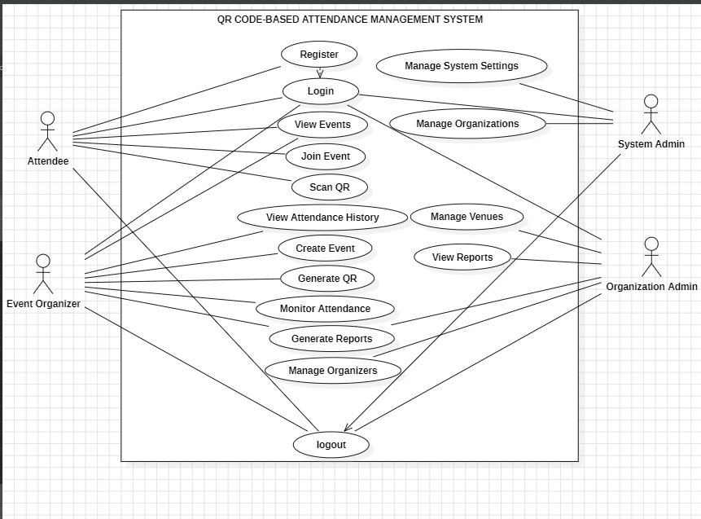

3.8 System Flow Description
The system flow begins when a user registers and logs into the system. If the user is an event organizer, the user creates an event and selects a venue. The system stores the event details in the database. Attendees can then view and join the event. If the event requires an access code, the attendee must enter the correct code before joining.
When the attendance time reaches, the organizer displays the live QR code. The attendee scans the QR code using a phone or any supported mobile device. The system sends the scanned information to the server for verification. If the information is valid, the system saves the attendance record together with time, device information and location details where available.
Finally, the organizer views attendance records and reports. These reports can be used for analysis, record keeping and decision making after the event.

3.9 Data Flow Description
The data flow of the system shows how information moves from users to the database and back to the users. The attendee provides personal details during registration, and the system stores them in the users table. The organizer provides event details, and the system stores them in the events table. When an attendee joins an event, the system stores the relationship in the participants table.
During attendance scanning, the attendee submits QR scan data, device information and location details. The system validates the information and stores the attendance record in the attendance table. Reports are generated by retrieving data from users, events, participants and attendance tables.

Figure 3.2: Data Flow Diagram
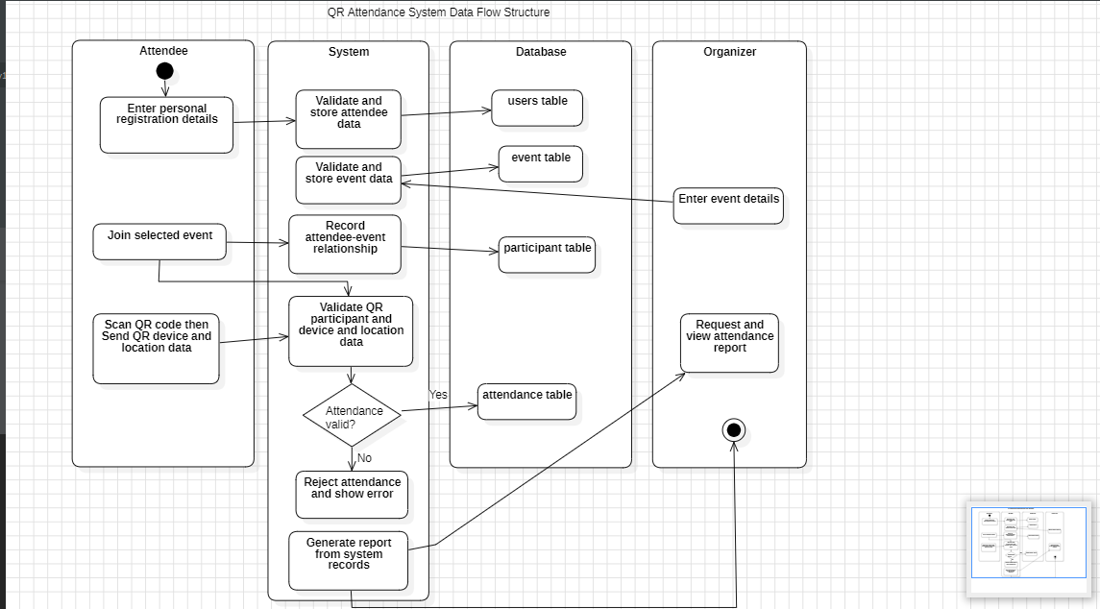

3.10 Development Methodology
The development methodology used in this project is the agile methodology. Agile was selected because it allows the system to be developed in small parts and improved through continuous feedback. This was suitable for the QR Code-Based Attendance Management System because the system has several modules such as user management, event management, QR code generation, attendance scanning, reporting and verification.
Using Agile, the system was developed in iterations. Each iteration focused on a specific part of the system. After completing one part, it was reviewed and improved before moving to the next part. This approach helped to identify errors early and make changes without waiting until the end of the project.

Table: 3.4 Development Methodology
Agile Phase | Activity in This Project
Requirement Gathering | Collected user needs from observation, interviews and document review
Planning | Planned system modules such as users, events, QR scanning and reports
Design | Designed database structure, user interface, system flow and verification process
Development | Implemented modules step by step using PHP, MySQL, HTML, CSS and JavaScript
Testing | Tested login, event creation, event joining, QR scanning, attendance recording and reports
Review and Improvement | Improved the system based on errors found during testing and user feedback
Agile methodology helped the project because changes could be made while development was still continuing. For example, after implementing QR scanning, additional verification features such as device information and location details were considered to improve attendance reliability.

CHAPTER FOUR

SYSTEM DESIGN

4.1 Introduction to System Design
System design explains how the proposed QR Code-Based Attendance Management System is planned before implementation. It shows the structure of the system, the technology used, the database design, the user interface design and the security design. A good system design is important because it guides development and ensures that the final system meets the requirements identified in Chapter Three.
The proposed system was designed as a web-based application for managing attendance during events. It allows different users to perform different tasks according to their roles. The design supports event creation, venue selection, participant joining, live QR code generation, QR scanning, attendance verification, attendance storage and report generation.

4.2 System Design Methodology and Technologies
The system was designed using a web-based design approach. This approach was selected because users can access the system through a browser without installing a separate application. A web-based system is also suitable for events because participants can use mobile phones to scan QR codes while organizers can use computers or tablets to manage events and view reports.
The system uses PHP for server-side processing. PHP handles user authentication, session management, role checking, event management, QR code validation, attendance recording and report generation. MySQL is used as the database because it supports structured data storage and can manage relationships between users, events, participants, venues and attendance records.
HTML is used to structure pages, CSS is used to style the interface, and JavaScript is used to support interactive operations such as QR scanning, live QR code display, attendance submission and location capture. The system can run on a local server environment such as XAMPP, which provides Apache, PHP and MySQL.

Table: 4.1 System Design Methodology and Technologies
Technology | Purpose in the System
PHP | Processes server-side logic, authentication, event management and attendance submission
MySQL | Stores users, organizations, venues, events, participants and attendance records
HTML | Provides the structure of web pages and forms
CSS | Controls page layout, colors, spacing and responsive design
JavaScript | Handles QR scanning, live QR display, browser interaction and location capture
XAMPP/Apache | Provides local server environment for running the system

4.3 System Architecture Design
The system follows a three-layer architecture. The first layer is the presentation layer, which contains the pages used by attendees, organizers and administrators. The second layer is the application logic layer, which processes user requests, validates data and controls system operations. The third layer is the data layer, which stores and retrieves information from the database.
In the presentation layer, users interact with pages such as login, registration, dashboard, events, create event, scan attendance, attendance records and reports. In the application logic layer, the system checks user roles, validates event access, confirms attendance windows and prevents duplicate attendance. In the data layer, the system stores records in MySQL tables.
This architecture was selected because it separates the user interface from the business logic and database. This makes the system easier to maintain and improve in the future.

Figure 4.1: System Architecture Diagram
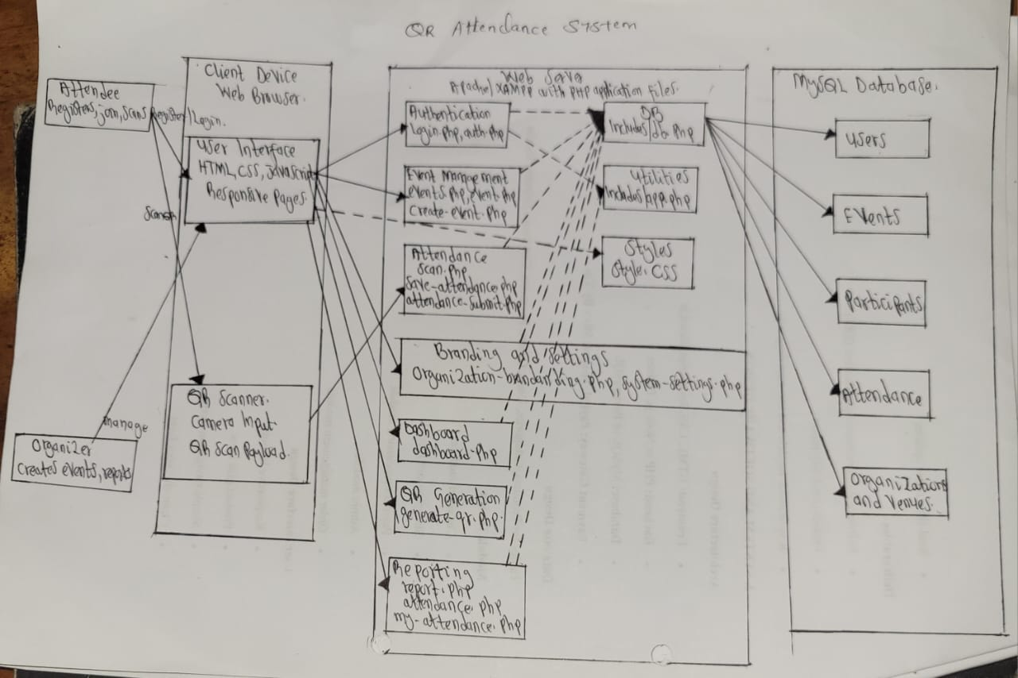

4.4 Database Design
The database was designed to store all important system information. The main tables include users, organizations, venues, events, participants, attendance, attendance logs and system settings.

Table: 4.2 Database Design
Table Name | Main Fields | Description
users | id, name, email, phone, password, role, organization_id, attendee_type, reg_no, department | Stores account details and identifies the role of each system user
organizations | id, name, description, logo, contact_email, is_active | Stores organization information and supports organization-based management
venues | id, organization_id, name, address, city, latitude, longitude, capacity | Stores event venues and coordinates used for location verification
events | id, name, description, date, time, end_time, attendance_start, attendance_end, venue_id, location_lat, location_lng, registration_mode, access_code | Stores event details and attendance settings
participants | id, user_id, event_id, participant_name, participant_email, access_code | Stores users who have joined or registered for an event
attendance | id, user_id, event_id, user_name, user_email, device_info, scan_lat, scan_lng, scan_ip, distance_from_venue, attendance_status | Stores attendance records and verification details
attendance_logs | id, attendance_id, user_id, event_id, action, details, created_at | Stores actions and notes related to attendance recording
system_settings | setting_key, setting_value, updated_at | Stores general system configuration such as system name, logo and theme settings
The database relationships help the system organize data properly. A user can create many events, and a user can attend many events. An event can have many participants and many attendance records. A venue can be used by many events. This relationship makes it possible to generate attendance reports for a single event or for several events.
The attendance table is one of the most important tables because it stores the actual proof of attendance. It keeps user details, event details, scan time, device information, location details and attendance status. This helps organizers verify whether the attendance was recorded correctly.

Figure 4.2: Entity Relationship Diagram
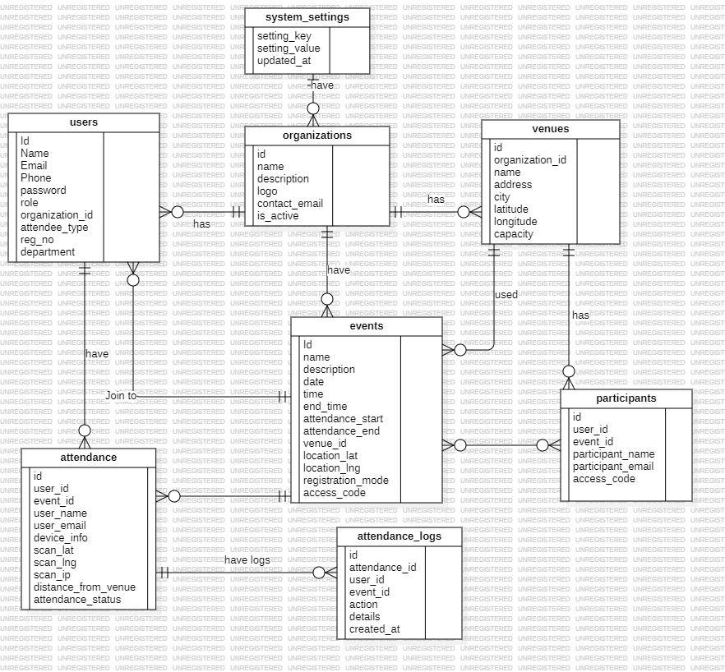

4.5 Input, Process and Output Design
The input design identifies the information entered into the system. The main inputs include user registration details, login credentials, event details, venue details, access codes, QR scan data, device information and location coordinates.
The process design explains what the system does with the input. For example, when a participant scans a QR code, the system validates the QR code, checks if the event exists, confirms that the attendance window is open, checks whether the participant joined the event and prevents duplicate attendance. If all conditions are valid, the system saves the attendance record.
The output design shows the information produced by the system. Outputs include dashboard statistics, event lists, live QR code display, attendance records, attendance status, device information, distance from venue and attendance reports.

Table: 4.3 Input, Process and Output Design
Input | Process | Output
User registration details | Validate and save user account | Created user account
Event details | Validate event data and save event | Created event record
Venue coordinates | Save venue location for future verification | Venue record with map location
QR scan data | Validate QR, event, user and attendance window | Recorded attendance
Attendance records | Analyze and count attendance data | Reports and statistics

4.6 Security Design
Security was considered in the system design because attendance records and user information must be protected. The system uses login authentication to make sure that only registered users can access protected pages. It also uses role-based access control so that users can only perform activities allowed by their roles.
The system reduces false attendance by requiring attendees to join an event before scanning. It also validates the QR code and checks the attendance window before saving attendance. Duplicate attendance is prevented by checking whether the same user has already recorded attendance for the same event.
Device information, IP address and location details are captured during attendance recording where available. These details help organizers review suspicious attendance cases. The system also uses access codes for private events to control who can join.

4.7 User Interface Design
The user interface was designed to be clear, simple and suitable for both desktop and mobile users. The system contains pages for login, registration, dashboard, events, event creation, event details, live QR display, scanning, attendance records, reports, venues and system settings.
The attendee interface focuses on easy event access and fast attendance scanning. The organizer interface focuses on event management, QR display and attendance monitoring. The administrator interface focuses on managing organizations, venues, organizers and system settings.
The scan page was designed with mobile users in mind because most participants use smartphones to scan QR codes. The report pages were designed with tables and statistics so that organizers can quickly understand attendance results.

Figure 4.3: Login Page Interface
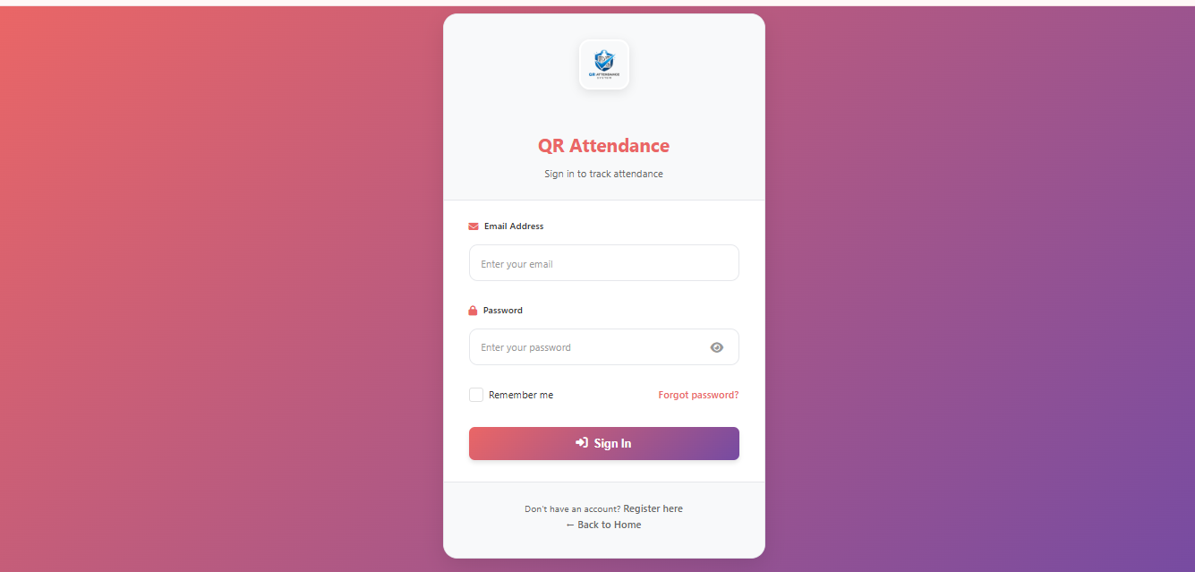

Figure 4.4: Dashboard Interface
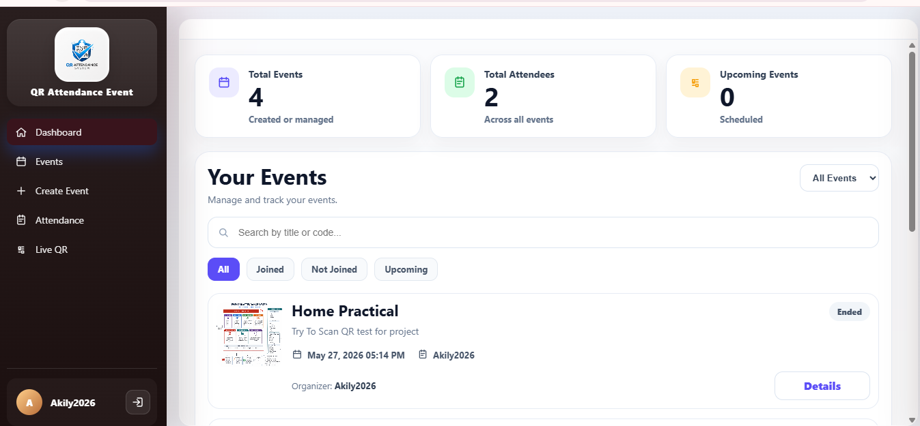

Figure 4.5: Event Creation Interface
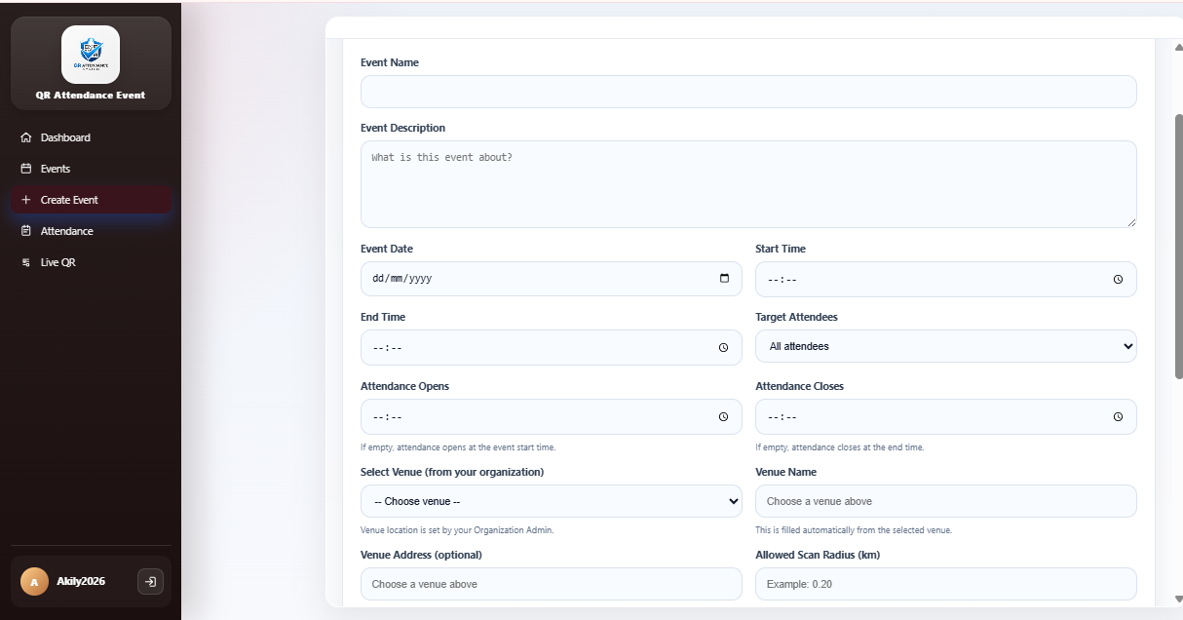

4.8 Navigation Design
Navigation design was considered carefully because the system has different users with different responsibilities. The system uses a dashboard layout where the main menu links are displayed according to the role of the logged-in user. This prevents users from seeing unnecessary functions and also makes the system easier to use.
For attendees, the navigation focuses on events, scanning attendance and viewing personal attendance history. For event organizers, the navigation focuses on event creation, event management, live QR code display, attendance monitoring and reports. For organization administrators, the navigation includes venue management, organizer management and organization events. For system administrators, the navigation includes organization management, event verification and system settings.
This design improves usability because users can quickly access the features that match their work. It also supports security because users are guided only to the areas they are allowed to use.

4.9 Validation and Error Handling Design
Validation was included in the system design to reduce wrong data entry and improve the quality of records stored in the database. During registration, the system checks important user details such as name, email, phone number and password. During event creation, the system checks required event details such as event name, date, time, attendance window and venue.
For attendance recording, validation is very important because the system must confirm that the QR code belongs to the correct event. The system also checks whether the attendance window is open, whether the attendee joined the event and whether attendance has already been recorded. These checks prevent wrong attendance records and duplicate attendance.
Error messages were designed to guide users when something goes wrong. For example, if an attendee scans outside the attendance window, the system informs the user that attendance is not open. If an access code is wrong, the system rejects the request and asks the user to enter the correct code.

4.10 Attendance Verification Design
Attendance verification was designed to improve the reliability of attendance records. The system does not depend only on QR scanning. It also uses login sessions, event participation, attendance windows, device information and location details. This combination makes it more difficult for attendance to be recorded falsely.
The live event QR code identifies the event attendance session, while the logged-in account identifies the participant. This means the QR code is not treated as the participant identity. Instead, the QR code confirms the event, and the system connects the attendance to the authenticated user.
Location verification was designed to support physical events. If the event venue has coordinates and the attendee allows location access, the system can compare the scan location with the venue location. If the participant is far from the venue, the system can mark the record for review or assign an attendance status based on the allowed radius.

4.11 Report Design
The report design was prepared to help organizers understand attendance data after scanning. Reports are important because organizers need to know the number of participants who attended, their details, attendance time and verification information.
The report page was designed to display attendance records in a table format. It includes attendee name, email, phone number, attendance status, scan time, device information and distance from venue where available. The system also provides statistics that help organizers analyze attendance trends.
The report design supports decision making. For example, an organizer can use the report to prepare certificates, evaluate participation, identify late attendance and keep official records for future reference.

4.12 Chapter Summary
This chapter presented the design of the proposed system. It explained the technologies used, system architecture, database design, input-process-output design, security design, user interface design, navigation design, validation design, attendance verification design and report design. The design shows that the system was planned to solve the problems identified in the requirement analysis chapter.

CHAPTER FIVE

SYSTEM IMPLEMENTATION

5.1 Introduction to System Implementation
System implementation is the stage where the system design is converted into a working application. The QR Code-Based Attendance Management System was implemented as a web-based application using PHP, MySQL, HTML, CSS and JavaScript. The implementation followed the requirements and design described in the previous chapters.
The system was developed to support the full attendance process, starting from user registration to report generation. The implementation focused on making the system practical for real event environments where organizers need fast attendance recording and participants need a simple scanning process.

5.2 Functionalities Implementation

5.2.1 User Registration and Authentication
User registration and login were implemented to allow users to access the system securely. A user provides details such as name, email, phone number and password during registration. During login, the system verifies the user credentials and creates a session for the logged-in user.
Role-based access was implemented to control what each user can do. For example, an attendee can join events and scan QR codes, while an event organizer can create events and view attendance records. Organization administrators and system administrators have higher permissions for managing venues, organizations and settings.

5.2.2 Event and Venue Management
Event management was implemented to allow organizers to create and manage events. The organizer enters event name, description, date, time, end time, attendance opening time, attendance closing time, target audience, venue and access mode. The system validates the event information before saving it in the database.
Venue management was implemented to support physical event locations. A venue includes name, address, city and map coordinates. These coordinates are important because the attendance system can compare participant scan location with the venue location.

5.2.3 Event Participation and Access Control
Event participation was implemented to allow attendees to join events before recording attendance. Public events can allow self-registration, while controlled events can require an access code. This helps organizers manage who is allowed to attend an event.
The system checks whether an attendee has joined the event before allowing attendance recording. This reduces false attendance because a user cannot simply scan a QR code for an event without being known by the system.

5.2.4 Live QR Code Generation
The live QR code function was implemented for event organizers. When attendance is open, the organizer displays the event QR code to participants. The QR code is linked to the event and is used to confirm that the attendance scan belongs to the correct event.
The live QR code approach is better for this system than giving each participant a printed QR code because it fits the real system flow. The participant is identified through the logged-in account, while the QR code identifies the event attendance session.

5.2.5 QR Scanning and Attendance Recording
QR scanning was implemented using browser-based camera access. The attendee opens the scan page, allows camera access and scans the QR code displayed by the organizer. If camera access fails, the system also supports manual live code entry and QR image upload.
After scanning, the system sends the QR data to the server for validation. The system checks whether the QR code is valid, whether the attendance window is open, whether the user joined the event and whether the user has already recorded attendance. If all checks pass, the system saves the attendance record.

5.2.6 Device and Location Verification
Device and location verification were implemented to improve trust in attendance records. The system captures browser information, device information, IP address and scan coordinates where the user allows location access. These details are stored together with the attendance record.
When venue coordinates are available, the system can calculate the distance between the participant scan location and the event venue. This helps organizers identify cases where attendance may have been recorded far from the event location.

5.2.7 Reporting and Monitoring
Reporting was implemented to help organizers analyze attendance records. The reports show attendance statistics, participant details, attendance status, device information, browser usage and distance from venue where available. This makes it easier for organizers to evaluate attendance without checking paper sheets.

5.3 Database Implementation
The database was implemented using MySQL. The system stores user accounts, organizations, venues, events, participants, attendance records, attendance logs and settings. The database was designed to support data accuracy, easy retrieval and reporting.
The attendance table was implemented with several verification fields. These include user_id, event_id, user name, user email, phone number, device information, scan latitude, scan longitude, scan IP address, browser information, distance from venue, attendance status, verification method and notes. This makes the attendance record more detailed than a normal manual register.
The database also supports dashboard statistics and reports. For example, the system can count total events, total participants, total attendance records and attendance records for a selected event.

5.4 User Interface Implementation
The user interface was implemented using HTML, CSS and JavaScript. The system uses a dashboard layout with a side navigation menu on desktop and mobile-friendly navigation for smaller screens. This makes the system usable on different devices.
The login and registration pages allow users to access the system. The dashboard gives users a summary of activities. The event pages allow attendees to browse and join events. The create event page allows organizers to enter event details and select venue information. The scan page allows attendees to scan QR codes using a mobile camera. The report page allows organizers to view attendance results.
The interface was designed to be simple because many users may not have advanced technical knowledge. Buttons, forms, tables and messages were used to guide users through the system.

5.5 System Testing and Evaluation
System testing was conducted to confirm that the main functions of the system work correctly. Testing was important because attendance systems must be reliable. If attendance is recorded wrongly, the organizer may make wrong decisions based on incorrect data.
The testing process focused on functional testing, validation testing, security checking and usability evaluation. Functional testing checked whether the system features worked as expected. Validation testing checked whether the system rejected wrong or incomplete data. Security checking focused on login and role-based access. Usability evaluation checked whether the system was easy to use.

Table: 5.1 System Testing and Evaluation
Test Case | Test Activity | Expected Result | Result
TC1 | Register a new user with valid details | User account is created successfully | Passed
TC2 | Log in using correct credentials | User is redirected to the dashboard | Passed
TC3 | Log in using wrong credentials | System rejects login and shows an error message | Passed
TC4 | Create an event with all required details | Event is saved and displayed in event list | Passed
TC5 | Create an event without required details | System requests missing required information | Passed
TC6 | Join an open event as an attendee | Participant record is created | Passed
TC7 | Join a code-based event with wrong code | System rejects the request | Passed
TC8 | Display live QR code for an event | System shows QR code during attendance window | Passed
TC9 | Scan valid QR code during attendance window | Attendance is recorded successfully | Passed
TC10 | Scan QR code after already recording attendance | System prevents duplicate attendance | Passed
TC11 | Scan QR code outside attendance window | System rejects attendance recording | Passed
TC12 | View attendance report | System displays attendance records and statistics | Passed
The test results show that the system meets the main functional requirements. It allows users to register, organizers to create events, attendees to join events and attendance to be recorded through QR scanning. The system also prevents duplicate attendance and supports report generation.

5.7 Testing Evidence
Testing evidence is important because it shows that the system was tested using real system screens. The following screenshots should be inserted to support the testing results shown above.

Table: 5.2 Testing Evidence
Evidence No. | Screenshot Required | Purpose
Figure 5.1 | Login Success Screenshot | Shows that a registered user can log into the system successfully
Figure 5.2 | Event Creation Screenshot | Shows that an event organizer can create an event
Figure 5.3 | Live QR Code Screenshot | Shows the QR code displayed by the organizer during attendance time
Figure 5.4 | QR Scan Success Screenshot | Shows that attendance was recorded after scanning a valid QR code
Figure 5.5 | Attendance Report Screenshot | Shows attendance records and statistics after participants have scanned

Figure: 5.1 Event Creation Screenshot
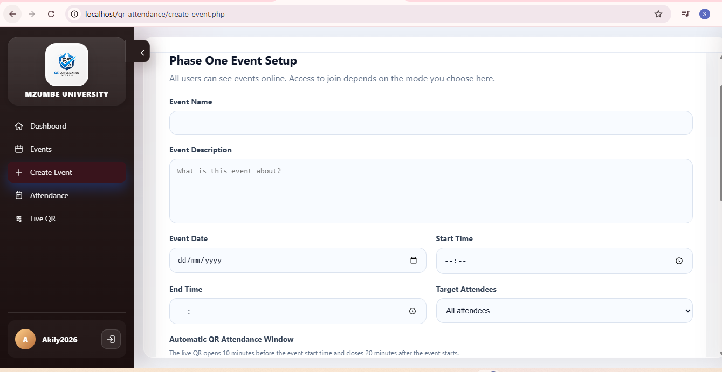

Figure: 5.2 Live QR Code Screenshot
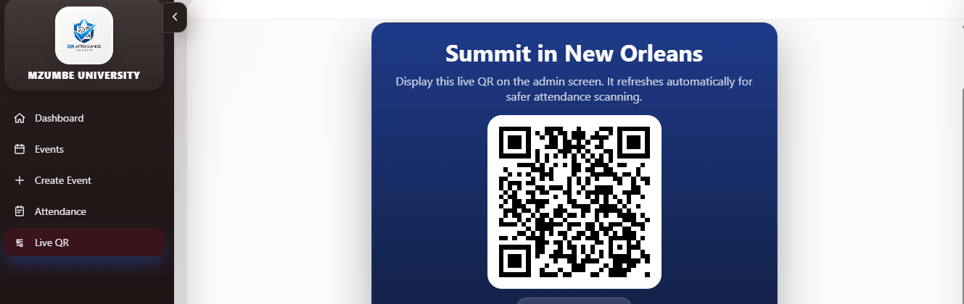

Figure: 5.3 QR Scan Success Screenshot
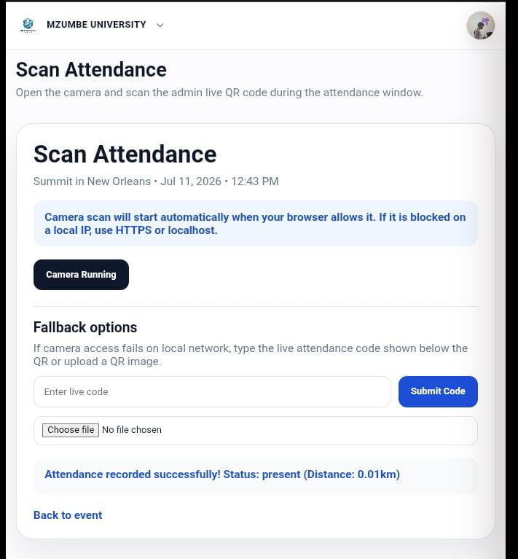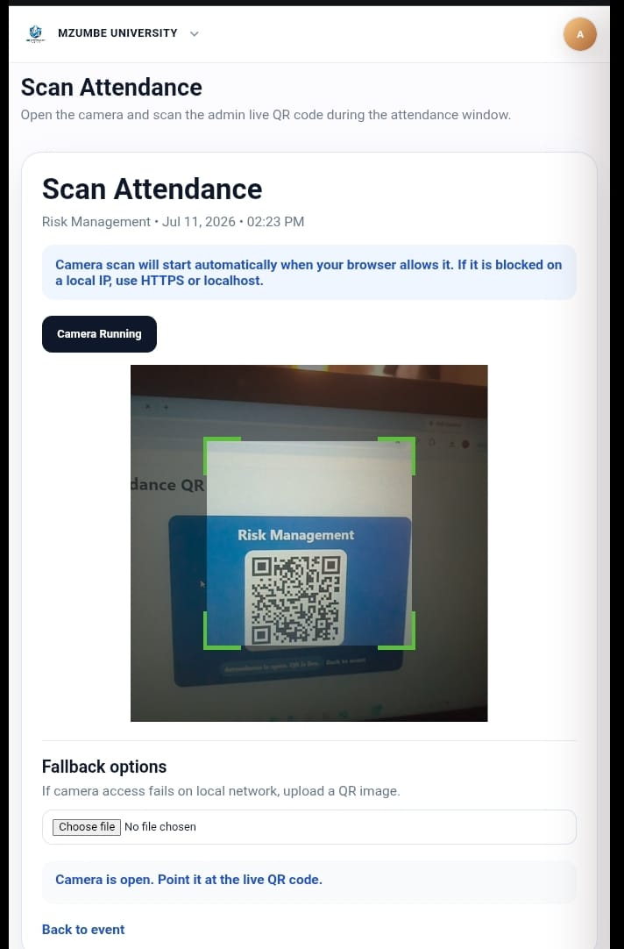

Figure: 5.4 Attendance Report Screenshot
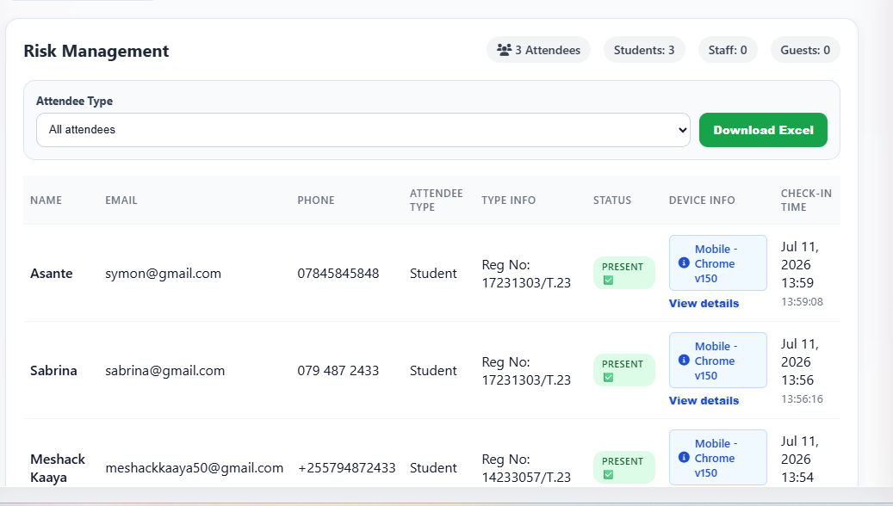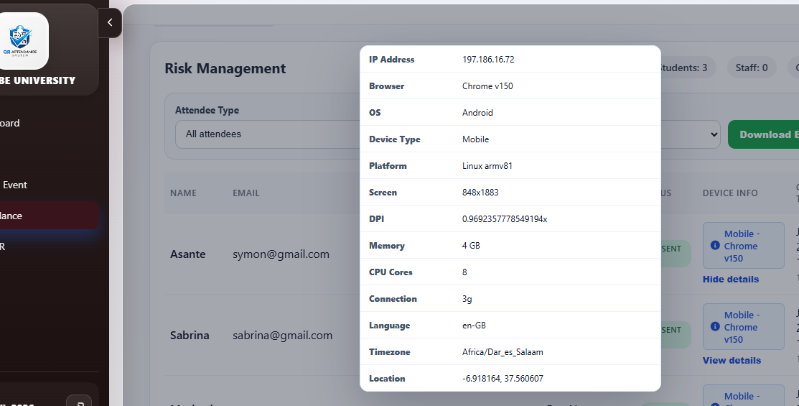

5.6 System Evaluation
The system was evaluated based on speed, accuracy, usability, security and reliability. In terms of speed, the system improves attendance recording because scanning a QR code takes less time than writing details on paper. In terms of accuracy, the system reduces unclear handwriting, missing information and duplicate manual entries.
In terms of usability, the system is simple because users interact with normal web pages and mobile scanning. In terms of security, the system uses login, role-based access, event joining, QR validation and attendance window checking. In terms of reliability, attendance records are stored in the database and can be retrieved for reports.
The evaluation shows that the system is suitable for seminars, workshops, meetings and conferences. It may depend on internet access, browser support and user permission for camera or location, but it still provides a better solution compared to manual attendance recording.

5.7 Development Environment
The system was implemented in a local development environment before testing. XAMPP was used because it provides Apache server, PHP and MySQL in one package. This made it possible to run the system locally, create the database and test the pages through a browser.

Table: 5.3 Development Environment
Tool or Environment | Use in Implementation
XAMPP | Provided Apache server, PHP and MySQL for running the system locally
PHP | Implemented backend logic and database operations
MySQL/phpMyAdmin | Created and managed database tables and records
Web Browser | Tested system pages, QR scanning and reports
Code Editor | Edited PHP, HTML, CSS and JavaScript files

5.8 Main System Files
The system implementation was organized into different files according to their functions. This structure makes it easier to maintain and understand the system.

Table: 5.4 Main System Files
File | Purpose
login.php | Allows users to log into the system
registrer.php | Allows new users to create accounts
dashboard.php | Displays summary information based on the logged-in user role
events.php | Displays available events for users
create-event.php | Allows organizers to create new events
event.php | Displays event details and event management options
generate-qr.php | Displays the live QR code for an event
scan.php | Allows attendees to scan QR codes and submit attendance
attendance-submit.php | Processes scanned attendance information and saves records
attendance.php | Displays attendance records
report.php | Displays attendance reports and statistics
venues.php | Allows management of event venues
includes/app.php | Contains shared functions, schema helpers, layout and system utilities

5.9 Attendance Recording Algorithm
The attendance recording process follows a clear sequence to make sure that only valid attendance is saved. First, the attendee must be logged into the system. Second, the attendee must open an event that has been joined. Third, the attendee scans the live QR code displayed by the organizer. Fourth, the system validates the QR code and event details. Fifth, the system checks whether the attendance window is open. Sixth, the system checks whether the attendee has already recorded attendance. Finally, the system saves the attendance record if all conditions are satisfied.
This process improves reliability because it combines QR validation with user authentication and event participation. It also reduces duplicate attendance because the system checks existing records before inserting a new record.

5.10 Implementation Challenges
During implementation, some challenges were considered. One challenge was camera permission because QR scanning requires browser access to the device camera. Some browsers may block camera access if permission is not granted. To reduce this problem, the system includes manual live code entry and QR image upload as alternative methods.
Another challenge was location permission. Some users may refuse location access, and some devices may provide inaccurate location data. The system therefore treats location information as a verification support feature rather than the only proof of attendance.
A further challenge was preventing false or duplicate attendance. This was handled by validating the QR code, checking the attendance window, confirming event participation and preventing the same user from recording attendance more than once for the same event.

5.11 Deployment Consideration
For deployment, the system can be hosted on a local server or an online web server. In a local event environment, the system can run on a computer connected to the same network. For wider access, the system can be hosted online so that attendees can access it using mobile internet.
Before deployment, the database should be created, required tables should be available, and the server should be configured correctly. Organizers should also test event creation, QR display and scanning before using the system in a real event.

5.12 Chapter Summary
This chapter explained how the system was implemented. It covered user authentication, event management, venue management, event participation, live QR code generation, QR scanning, attendance recording, device and location verification, reporting, database implementation, user interface implementation, testing, evaluation, development environment and implementation challenges. The implementation shows that the proposed system can operate as a complete attendance management solution for events.

CHAPTER SIX

CONCLUSION AND RECOMMENDATIONS

6.1 Summary of Achieved Objectives
The project achieved its general objective of developing a QR Code-Based Attendance Management System for events. The system was developed to improve the speed, accuracy and reliability of attendance recording during seminars, workshops, meetings and conferences.
The first objective was to design a system that generates a unique live QR code for each event or attendance session. This was achieved by implementing a live QR code page that organizers can display during the attendance window.
The second objective was to allow participants to record attendance by scanning the event QR code using a mobile device. This was achieved through the scan page, which allows participants to scan QR codes using a browser-based camera. Manual code entry and QR image upload were also included to support users when camera access is difficult.
The third objective was to store user, event, participant and attendance records in a digital database. This was achieved through the MySQL database, which stores records in organized tables such as users, events, participants and attendance.
The fourth objective was to enable organizers to monitor attendance records. This was achieved through attendance pages and report pages where organizers can view attendance records, participant details and attendance statistics.
The fifth objective was to generate attendance reports for record keeping and decision making. This was achieved through the reporting module, which displays attendance statistics, device information and attendance status.
The sixth objective was to reduce manual errors and minimize false attendance recording. This was achieved by replacing paper registers with digital scanning, preventing duplicate attendance and validating QR scans.
The seventh objective was to improve attendance verification using device and location details. This was achieved by capturing device information, browser details, IP address and scan coordinates where available.

6.2 Conclusion
The QR Code-Based Attendance Management System provides a practical and effective solution for managing attendance in events. It reduces the weaknesses of manual attendance systems by allowing participants to record attendance through QR scanning. This reduces delays, improves accuracy and makes attendance records easier to manage.
The system is useful because it supports the full attendance process. Organizers can create events, manage event access, display live QR codes, monitor attendance and generate reports. Attendees can join events and record attendance using mobile devices. Administrators can manage venues, organizations and system settings.
The system also improves attendance verification by using login accounts, event participation, attendance windows, device information and location details. These features make the attendance record more reliable than a simple paper register. Although the system depends on devices, browsers and network access, it remains affordable and suitable for many event environments.
In conclusion, the project has shown that QR code technology can be used to improve attendance management in seminars, workshops, meetings and conferences. The developed system meets the main project objectives and provides a strong foundation for future improvements.

6.3 Recommendations
Future development can improve the system by adding automatic certificate generation. This would allow organizers to issue certificates only to participants who successfully attended the event.
The system can also be improved by adding email and SMS notifications. These notifications can remind participants about upcoming events, access codes and attendance time.
Another recommendation is to add export options such as PDF, Excel and CSV. This would help organizers share attendance records easily with management or other stakeholders.
The system can also be improved by adding stronger offline support. This would help organizers record attendance in areas with weak internet connection and synchronize records when the connection becomes available.
In future versions, advanced verification methods such as facial recognition or biometric integration may be added for events that require higher security. However, these features should be optional because they may increase cost and complexity.
It is also recommended that organizers train users before using the system in large events. Short guidance can help participants understand how to join events, allow camera access and scan QR codes correctly.

6.4 Limitations of the System
The system depends on mobile devices, browser support and camera access for QR scanning. If a participant device has a poor camera or the browser blocks camera permission, scanning may fail. To reduce this problem, the system provides manual code entry and QR image upload options.
The location tracking feature depends on user permission and device GPS accuracy. If the user refuses location permission or the device provides inaccurate coordinates, location verification may not be fully reliable.
The system also depends on server and database availability. If the server is not running or the database connection fails, users cannot record attendance. Proper server maintenance is therefore important for reliable use.

6.5 Contribution of the Project
The project contributes a practical attendance management solution for event environments. It shows how QR code technology can be used to reduce problems found in manual attendance systems. The project also demonstrates how a web-based system can support attendance recording without requiring expensive hardware such as biometric scanners or RFID readers.
Another contribution is the use of additional verification information such as device details and location coordinates. These features make the system stronger than simple online attendance forms because organizers can review more information about each attendance record.

6.6 Future Work
Future work can focus on adding more advanced reporting features. For example, the system can include automatic charts, attendance comparison between events and export of reports in Excel or PDF format.
The system can also be improved by adding certificate generation. After attendance is confirmed, participants who attended can automatically receive certificates. This feature would be useful for seminars, workshops and training events.
Another area for future work is offline attendance support. This would allow attendance to be recorded even when internet connection is weak, then synchronized later when the connection is available.
Future development may also include notification services such as email or SMS reminders. This would help participants remember event time, venue and attendance instructions.

6.7 Final Remarks
The development of the QR Code-Based Attendance Management System has shown that digital systems can improve attendance management in a simple and affordable way. The system supports the real needs of event organizers and participants by reducing manual work, improving data storage and supporting faster attendance recording. Although the system can still be improved in the future, it provides a strong foundation for managing attendance in seminars, workshops, meetings and conferences. With proper use and maintenance, the system can help organizations keep accurate attendance records and make better decisions based on reliable data.

REFERENCES
Adewole, K. S., Abdulsalam, S. O., Babatunde, R. S., Shittu, T. M., & Oloyede, M. O. (2014). Development of fingerprint biometric attendance system for non-academic staff in a tertiary institution. Computer Engineering and Intelligent Systems, 5(2), 62-70.
Agarwal, S., & Bansal, S. (2013). Online attendance management system using RFID with object counter. International Journal of Information and Computation Technology, 3(3), 131-138.
Denso Wave Incorporated. (n.d.). History of QR Code. Retrieved from https://www.qrcode.com/en/history/
Foster, P., & Halfond, W. (2014). Using QR codes for mobile learning and attendance tracking. Retrieved from https://www.researchgate.net/publication/320123787
Google LLC. (n.d.). Google Forms. Retrieved from https://forms.google.com
Hendrickson, C., & Au, T. (2008). Project management for construction: Fundamental concepts for owners, engineers, architects and builders. Carnegie Mellon University.
Jain, A. K., Ross, A., & Prabhakar, S. (2004). An introduction to biometric recognition. IEEE Transactions on Circuits and Systems for Video Technology, 14(1), 4-20.
Kumar, A., & Bansal, S. (2018). Web-based attendance management system. International Journal of Computer Applications, 179(7), 15-19.
Laudon, K. C., & Laudon, J. P. (2020). Management information systems: Managing the digital firm (16th Ed.). Pearson.
Martin, J. (1991). Rapid application development. Macmillan.
Okokpujie, K. O., Noma-Osaghae, E., John, S. N., Grace, K. A., & Attai, W. (2017). A facial recognition attendance system with SMS notification. Proceedings of the IEEE International Conference on Computational Science and Computational Intelligence, 239-244.
Pressman, R. S., & Maxim, B. R. (2020). Software engineering: A practitioner's approach (9th Ed.). McGraw-Hill.
Rumbaugh, J., Jacobson, I., & Booch, G. (2005). The unified modeling language reference manual (2nd Ed.). Addison-Wesley.
Schwaber, K., & Sutherland, J. (2020). The Scrum Guide: The definitive guide to Scrum. Scrum.org.
Singh, R., & Kumar, P. (2020). QR code based applications in attendance systems. Multimedia Tools and Applications, 79, 5395-5410.
Sommerville, I. (2016). Software engineering (10th Ed.). Pearson.
Turban, E., Pollard, C., & Wood, G. (2018). Information technology for management: On-demand strategies for performance, growth and sustainability (11th Ed.). Wiley.
Want, R. (2006). An introduction to RFID technology. IEEE Pervasive Computing, 5(1), 25-33.

